#### Method 2: Explode in a Working File, Swap and Copy/Paste:

In very limited circumstances, we may convert a DWG into REVIT objects by swapping the line styles in a temporary working file.

* Create a new file using the SFO template.
* Import the DWG into a Drafting View. Change the drafting view scale to match the DWG detail.
* Partial explode the DWG in this working file. Never explode the DWG in the actual project because this compromise the integrity of the project text styles, pattern definitions, line patterns and line styles.
* Select all objects in the drafting view and use the Selection Filter to select lines by DWG layer name, and swap with the appropriate standard Line Styles.
* Rebuild DWG hatches with standard Revit Filled Regions
* Swap DWG imported text style with standard Revit Annotation families. Add the appropriate leader type and rebuild dimensions. This is unfortunately a manual task.
* Identify opportunities to use Detail Components: Avoid retracing geometry suited to be part of a Revit detail component.
* Once all the DWG geometry is swapped with Revit definitions, copy and paste the detail into a project drafting view.
* Purge unused. Save as the detail in the

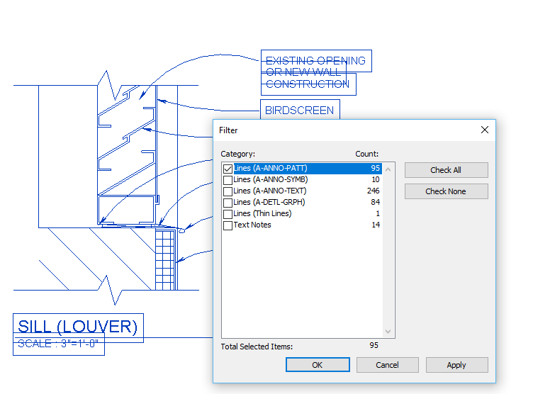

Figure 6.7‑2 Use the Filter Tool